DISD

XX/09/2022

I hereby declare that I did not plagiarize any content in this assignment and that this my own work.  
Signed:_______________

OPSC

t

Contents

Introduction 2

Design 3

Dences 6

# Introduction

Dioscuri. A guiding light…

In the advent of new technology, we strive to bring to the community the advancement of convenience to our daily lives. And for those who like to explore their local domain, we, proudly introduce our newest app, Dioscuri.

With the advancements into map applications, the GPS functional app, Dioscuri, can be the light guiding one’s path through the darkness of the local community.

Named after the Greek myth, the Dioscuri, are known for guiding lost people with divine intervention, and now the manifestation of their will be incarnated with the push of a button.



Please not, as this is subject is change all information is tentative and may undergo revision in the near future.

In the wondrous world of apps today, more and more conveniences are made for the public, from simple tools to the technology of today, various machines are created.

This does not just pertain to just physical machines, with our current technology. We can even make digital innovations through programming.

Through the marvel of applications, a lot of assist tools can be crammed in.

This comes to our main topic, the integration of maps into apps of today.

Yes, with the help of our mapping technology and the system of GPS machinery, even this once that could be called a godly power is at the fingertips of the common man today.

By installing map feasibilities, we can make applications that make use of tracking functions as well as guiding ones that are lost on their journey.

Welcome the era of mapping applications…

There are several capabilities pertaining to mapping applications that I find admirable enough, that I want to personally incorporate such facilities into the app, these include such abilities.

# Overview Of the Apps

**Polaris Navigation gps**

Program Details

Released Date 2019-07-27

Languages English

Category Education

Subcategory Geography

Operating systems android

File size

Total downloads 1894

License model Free

Price N/A

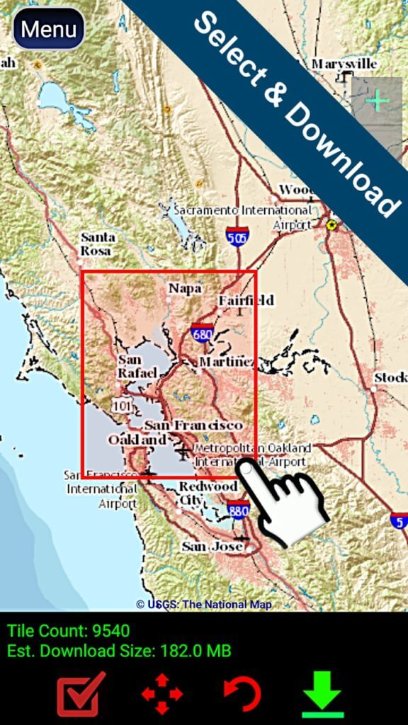 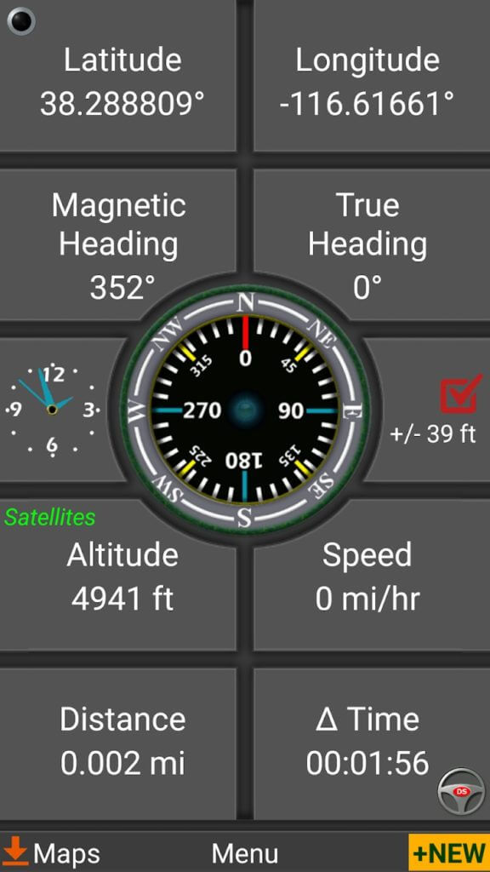

Polaris, named after the largest star in the constellation of Ursa Minor system, caters to the walking man. More specifically, it provides greater aids to people who hike.

Compared to the others, it assumes that the user will not be traveling by any vehicle, and provides help with things it deems that would be helpful for walking.

Though most of the other maps will skip over the details not covered by cap, this app goes into minute details that do not pertain to the road.

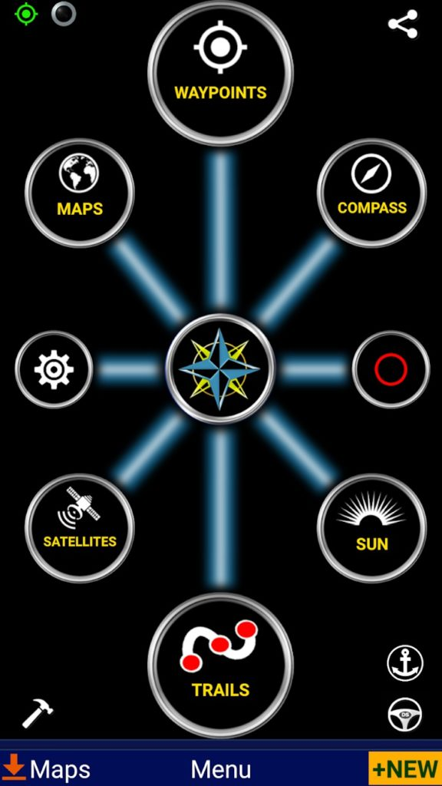

Taking note of paths and facilities that would be overlooked if a person had the convenience of a car. Hiking paths, notable fauna, this app is targeting the more outdoors happy person.

It has a functioning compass, complete with details such as latitude, longitude, degree reading, altitude and barometer.

This application however has the weakness of not being new user-friendly. The various options will take some time of getting used to, and it purposes are redundant to the casual person.

The GUI may appear confusing to people who do not understand them, and users might not consider the information critical enough to actually bother to understand them, deeming them unimportant.

**Sygic gps Navigation**

[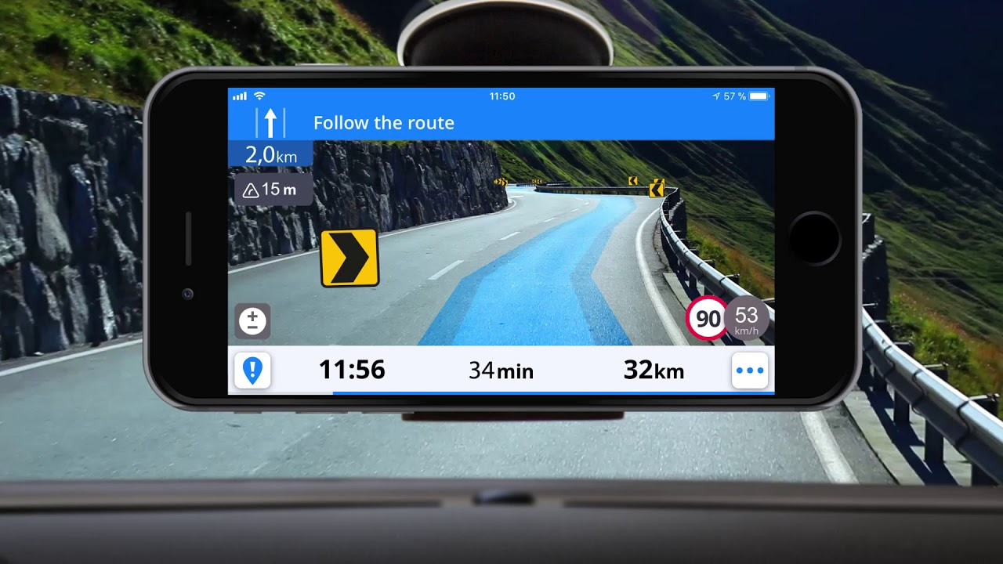](https://www.google.com/url?sa=i&rct=j&q=&esrc=s&source=images&cd=&ved=2ahUKEwjV0tD2uqDkAhWwSxUIHfxuCPAQjRx6BAgBEAQ&url=https://www.youtube.com/watch?v%3DcW975BidjLA&psig=AOvVaw0gpprSxRlPCKfi6LHUdknW&ust=1566906284390624)

Price: Free / $24.99 per year

A very popular app, specifically the most-installed mapping application which focuses on offline maps. In collaboration with a company called Tomtom, this app has included offline maps for every known country in the world.

Key features include free map, updates, voice guided GPS navigation and pedestrian capabilities for those on foot.

Although its main appeal is the offline capability of this app, it still has several functions that are only operational when a connection is established and a fee is paid. It provides limited aid to financial decisions such as providing details on the cheapest nearby parking lots and fuel stations and hints about the whereabouts of well-known speed cameras.

There is a free and online version of this product, obviously several of its best capabilities are locked unless one is willing to spend the extra financial leeway. There is a trial version that functions for a week when the program is first operational.

Continuing on with their additional features, they also off various add features, such as using the phone’s camera to display instructions over the view from your car. Mainly various eccentrics that are grandiose but provide little improvement in a practical environment.

**Scout gps**

Price: $24.99 annually

What was once known as Telenav, once rebranded, given a new fresh look and revived as Scout GPS.

Scout GPS main functions are all centered around the genic abilities of the map applications. Despite its core purpose it has nothing special about the its navigation options.

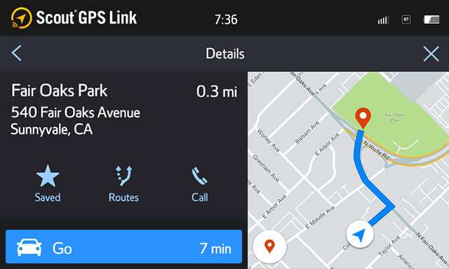

Rather its specialty belies in one of the subsystems, mainly it highlights its social aspects over its mapping. Having the capacities to have messages sent and received as well as for someone to call for you.

How does this app compare to applications that solely devote themselves to either social or navigating? It is lacking it comparison. Finding other applications that outdo either is a simple task. That said, it might be a **little trouble some for such people to manage two different apps at once, this is where this app capitalizes.**

By focusing on the positives of two often different conveniences, it combines them both. It strong point is its flexibility, freely to change between either function without the added load times and switching screens.

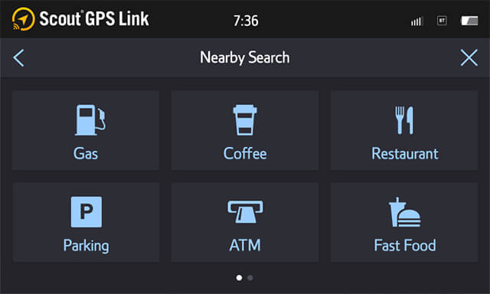

This application should be praised for its willing to adapt though. In today’s world. Social media is prevalent. With the disease of Facebook inspiring global communication, people have almost evolved a need to fulfill social obligation. This app takes care of that need. The users will even advertise the app, wanting more of their acquaintances to also be users as well.

This app comes with a trial period of three years, after which it will cost a yearly fee of $24.99.

# Strengths and weaknesses of the App

**Polaris Navigation gps – Strengths**

Integration with Google Maps.

Fully functioning compass with latitude, longitude, degree reading, altitude, and barometer.

* Interchangeable units
* Supports various map types (Atlas, NASA, Topographic, USGS, Toporama, Nautical)
* Download detailed continental maps
* Send current position via email or SMS
* Track sunrise/sunset
* Record trails (Background trail recording)
* Create waypoints
* Off-road, on-road, at sea

(Billa, Polaris Navigation GPS: Navigation for the Explorer in You, 2019)

Polaris Navigation gps – **Weaknesses**

* Ease-of-use could be better.
* Certain parts of the app cause the phone to be laggy.
* Doesn’t really provide you with off-road tracks (you have to record it first).
* Features most of them are not at their fullest to satisfy the customer.

(Billa, Polaris Navigation GPS: Navigation for the Explorer in You, 2020)

Sygic gps Navigation – Strengths

* The app gives you accurate direction it provides the user with some accurate exact path to take that leads the user to their destination. And that will lead the user to save some time by being lost and instead the user will reach their destinations on time.
* In this app you are permitted to save any maps of you of your city or even country. This technique gives more advantage to way towards the user’s destination.
* It’s possible to get the app free out of charge and also this app in some of its features it may exclude some unnecessary charges.
* Sygic gps navigation comes with an important system that gives advantage to the user’s this system is called (Head Up Display) this system is vital in a way that it processes any instructions it receives from the user very faster and keeping the user’s or the driver’s attention on the road.
* The app was made to become completely harmless to any android device, meaning the user has a safe mapping system installed on their devices.

(Unknown, Head-up Display (HUD), 2022)

(Unknown, Syguc Gps Navigation Apk (All Unlocked/Patcher), 2022)

Sygic gps Navigation – Weaknesses

* Offline some features on this apps system are slow to use.
* This app is getting slow to use in the period when the user is the maps offline.
* The app allows the user’s to access through any form of map they wish in any cities or countries but the app has an issue of providing inaccurate maps or direction for the user to where they want to go and that will decrease the trust from it regarding its users.

(Unknown, Head-up Display (HUD), 2022)

(Unknown, Syguc Gps Navigation Apk (All Unlocked/Patcher), 2022)

Scout gps - **Strengths**

* The app comes with a flexibly navigation feature that it fit’s to any of your car’s multimedia display And provides the user’s talk with and talk service through connecting the user’s phone via a car’s USB and as well as Bluetooth.

(Telenav, 2022)

* the app calculates and shows visible time to how much it will take from the current destination the user is at currently towards the destination they heading to.
* This app allows one to input or enter their places they looking to heard to by using the search box and get a lot of suggested places within the parameter of searching, this app is made to quick thinking for the customers without the customer writing in full name the place landmarked which they heading to.
* The app comes with the interesting system that easily can discover some well-known places even the customer did not intend to got to that particular destination just to give the driver more trust to the app to be used that it can track some unexpected important local landmarks that are usually visited by many tourists.
* The app comes with flexibly type of a different search box called the Voice command, this command also makes it easy for the app by to process locating places the driver wants to go to very quickly or at a faster pace.
* The app assists the customer by avoiding many traffic congestions that can be possible along the road and the app may assist you in by suggesting other possible routines to take so that the user can reach their destinations at a fast pace without any obstacle.
* No need to download unnecessary more updates about the app or its features as the app already comes with almost every necessary feature with it that would be vital for the user to use it.

(Dominion, 2022)

Scout gps - **Weaknesses**

* If the app its used continuously with its running gps in the background it can consume more energy on the battery for a pointless reason.
* Based on the apps history it is not advised to get the older version of the app and this lead’s to some user’s to miss out some layout of the features that they liked on the older versions they used about the app being forced to get the latest version of the app so to see more updated features working flexibly to any devices at a faster pace.
* This app may not have Mapstream mode or other necessary tools to be used at from 2017 versions and older versions.
* When it comes in terms of vehicles the app’s features as well as its experience may be varying according to the vehicle mode or manufacturing company, and this may become uncomfortable to some users as they may wish to use the app to some of their vehicles but which the certain system or version of the app may not be supporting or may not be available on for those type of vehicles.
* Cables and Bluetooth devices and also networks often just don’t often work for no reason causing some frustrations having to restart the app or reload the system on any device or even vehicle devices for the app.

(Dominion, 2022)

(Unknown, Syguc Gps Navigation Apk (All Unlocked/Patcher), 2022)

# How you think the app was implemented based on your knowledge of Android Studio App development

**Polaris navigation gps**

The app comes with the automatic system to download maps if the user requires more of the specific locations for viewing that they will traveling to meaning the app is connected to any online tool that feeds and updates the user through the system for any special offers for maps.

Google Maps is specified to be used as a tool to assist the app with updating of any maps that are retrievable online for any location for the user to travel to.

(Software, 2022)

**Sygic gps Navigation**

The app does provide guidance to the destination intended by the user even to the extend of going through that process offline with out internet meaning it provides offline mapping stream.

But the app also has some functions where the user might find it necessary to update any map they wish to use meaning they have to process the app with online tools like google maps through forcefully using the Internet to succeed for that service.

(Sygic GPS Navigation, 2019)

**Scout gps**

Some of the features of the app such as map streaming and finding some gas stations and about traffic information they demanding to be powered by real time cloud information. But according to the app’s functions listed the app uses google online tools.

# A list of the best features of all the apps that you want to use in your final app

**Polaris Navigation gps**

* It comes with option where you can download adventuring maps to adventure around for some activities like fishing, mountain biking, hunting, camping.
* You have options to share your location with other destinations or friends.
* The app comes with the feature where you can navigate in a marine environment or the ocean.
* The app comes with features such as where you are provided with directions on the street as well as navigation for road through the availability of a pipeline which is digital which means the power polaris has a power connection within the space of google maps app within the user’s device.
* The app has other interesting features, but they are currently on the apps on another premium version currently.

(Software, 2022)

**Sygic gps Navigation**

* the system can record what’s happening on the road then gives you options to go ahead or shows other routes to take
* the app comes with a system which does recognize signs on the road.
* The app has a feature called (Head – Up Display) this feature can just project the navigation system into your sight on your window screen to assist the driver with a more cautious driving at night.
* Cockpit – this feature will show the driver the performance of their car, this feature measures your speed you are driving with and measures the G Force to assist the driver to drive safely.
* Dashcam – this feature gives the driver the chance to save record the road ahead using a video option for any accidents that may occur or any other kind of traffic destruction while on the other side the app navigates along the road the other side to help you drive accurately.

(Sygic GPS Navigation, 2019)

**Scout gps**

* **Turn-By-Turn Directions** – feature allows you to save or keep all your destinations or locations that are your favourite, and you can also have a feature of a prompted voice for turn-by-turn directions.
* **Voice Activated Convenience** – this feature provides with some options on the system which have directions as well as some other on-road functions are also easy to access through entune’s voice recognition that’s on a steering wheel.
* The app lets you connect to your smart phone and cloud.
* You can search for gas stations to refill, and you can also view gas prices before you reach to any of the nearby gas stations on course.

(Unknown, Scout GPS Link, 2022)

# Design

To begin with our design we must, first ask ourselves who are our target audience, the answer is of course the general public. Is that too wide a range? Yes. Therefore we establish our application on what we belive the average person would find more convenient.

User-friendlessness is our bread and butter in our app. And while this may be too simple for the dedicated digital citizen or plain for the more youthful-minded, this is general use and does not require much effort to overly familiarize the user of its capabilities.

Common themes

As the proud manufacturer of this design, we of course seek to dye the app in our own colours, following that logic we stick to iconic colours to establish recognition.

We are also a firm believer in making our logo attire the app in every instance available.

That said, this is intended as an informative application and thus we will use design applicably as necessary. For example the strict use of sans serif fonts when critical information is displayed.

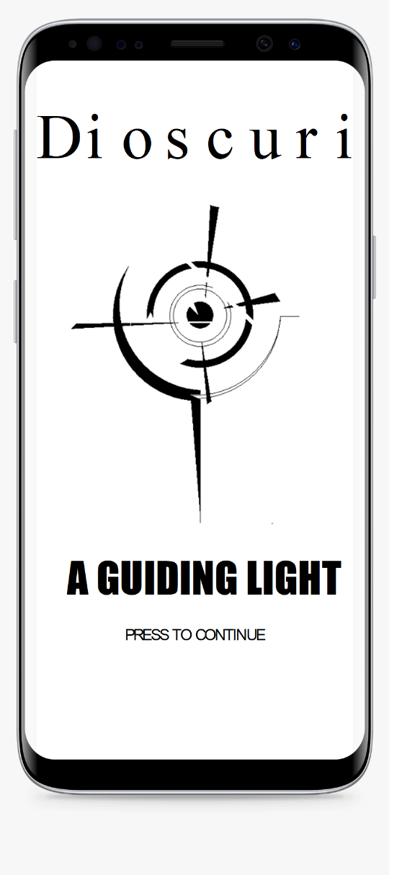

Start up

As many applications have a loading screen, we feel our time is spent spreading word of our wonderous application. And thus proudly display our logo and accompanying slogan.

Our aim is to further burn our image across the user’s retinas, insuring our image is synthesise with map location.

Introduction

If it is detected that the user is new to the program and has no prior information about this app, a short tutorial text will appear guiding the operator a quick example of how the app works, of course one can also skip the phase via an option if necessary.

The app will also ask the operator for a username which can be filled in. This allows the application to feel more personal, such as welcoming one with their own preferred name. This feature currently has no further use other than addressing the operator as prompted has no further influence on the app for the upcoming future and remains mostly decorative.

**Innovative features**

• You can ping when the user is in the vicinity of a user specified location.

• You can save the locations of places as the user desires.

• Filter – for to select certain locations via their function or attributes.

• You can format or refresh the app by deleting all saved locations.

• Looking for latest statistics that shows about which the record for times spent using the app and how much distance is covered.

• You can multiple locations and you can give them a nickname for the user’s convenience..

**ERD Diagrams**

**Project plan**



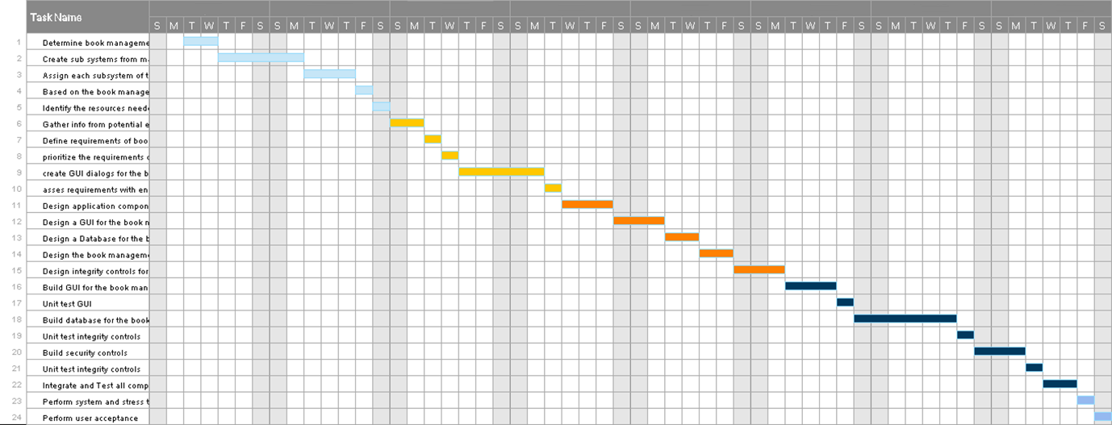

**Conclusion**

GPS applications are more or less common in daily life, while this means that people frequently use them, there are several hundreds that can do what the common app can do. This forces us to search for individuality and features that aspire to be unique.

Since we do not have the favor of beings a household name, we strive to put our face and signature to let people recognize us as a placebo for safe travels.

That said, once we have our foot in the door, our features need to emphastize with easy use for the common folk.

,

D i o s c u r i

A GUIDING LIGHT

PRESS TO CONTINUE

# Conclusion

As we reach the ending of the journey for the research the group has went through it has been an effective progress to display the three apps about how they work to provide the society about effective guidance of local landmarks systems so that people can travel on foot or by bike, motorcycle, car to wherever they wish to any destinations. In end we can finally conclude by stating that as the group we went about being able to show up each of the 3 local landmarks apps namely polaris Navigation gps, sygic gps navigation, scout gps. The apps provide their own interesting important features to help people get what they expect from them for travelling reasons, we will use the experience we gained from the 3 local landmarks apps that we went into research about for structuring our own planning for our own local landmark app that we will be creating to meet the needs of the users what they need to accomplish for their travelling activities effectively as they expect.

# Reference

Billa. (2019, July 7). *Polaris Navigation GPS: Navigation for the Explorer in You*. Retrieved from joyofandroid.com: <https://joyofandroid.com/polaris-navigation-gps-app/>

Billa. (2020, September 24). *Polaris Navigation GPS: Navigation for the Explorer in You*. Retrieved from Joy of Android: <https://joyofandroid.com/polaris-navigation-gps-app/>

Dominion, N. P. (2022, September 20). *The NEW and Improved Scout GPS Link Overview*. Retrieved from Youtube: <https://www.youtube.com/watch?v=0XypJXjmerc>

Hindy, J. (2019, August 2019). *10 best GPS apps and navigation apps for Android!* Retrieved from www.androidauthority.com: <https://www.androidauthority.com/best-gps-app-and-navigation-app-for-android-357870/>

Software, D. (2022, September 20). *Polaris GPS Navigation for Android*. Retrieved from download.cnet.com: <https://download.cnet.com/Polaris-GPS-Navigation/3000-20426_4-75759719.html>

Sygic GPS Navigation. (2019, August 24). *Sygic GPS Navigation*. Retrieved from www.sygic.com: <https://www.sygic.com/gps-navigation/>

Telenav, I. (2022, September 20). *Scout GPS Link*. Retrieved from apkpure: https://m.apkpure.com/scout-gps-link/com.telenav.app.android.scout4cars

Unknown. (2019, August 26). *Polaris GPS Navigation: Hiking, Marine, Offroad*. Retrieved from polaris-navigation-system.soft112.com: <https://polaris-navigation-system.soft112.com>

Unknown. (2022, September 20). *Head-up Display (HUD)*. Retrieved from Sygic: sygic.com/what-is/head-up-

Unknown. (2022, September 20). *Scout GPS Link*. Retrieved from Falmouth Toyota: <https://www.falmouthtoyota.com/scout-gps-link.html>

Unknown. (2022, September 20). *Syguc Gps Navigation Apk (All Unlocked/Patcher)*. Retrieved from APKMODGET: <https://apkmodget.com/apps/sygic-gps-navigation-apk/#Advantages_and_disadvantages>